Step by Step Appium & Android Setup Instructions (Windows)
- Download Java
Install from Java Archive Downloads - Java SE 17.0.12 and earlier
Check installation in terminal by running the command:
javac -version

- Download Android Studio
Install from Download Android Studio & App Tools - Android Developers
Get the SDK folder path from the settings window. (C:\Users\<user-name>\AppData\Local\Android\Sdk)
Android Studio will be installed in “C:\Program Files\Android\Android Studio\bin”

- Download Node
Install from Node.js — Download Node.js®
Check installation in terminal by running the command “node”.

- Set Environment Variables
JDK Path:
- C:\Program Files\Java\jdk-17\bin
Android SDK Path:
Set a new variable ANDROID_HOME = C:\Users\<user-name>\AppData\Local\Android\Sdk
Also set the below in PATH variable.
- C:\Users\autom\AppData\Local\Android\Sdk
- C:\Users\autom\AppData\Local\Android\Sdk\platform-tools
- C:\Users\autom\AppData\Local\Android\Sdk\tools
- C:\Users\autom\AppData\Local\Android\Sdk\tools\bin
Note: The paths mentioned in points (c) and (d) will be hidden initially. Unhide them using below:
Open Android Studio. Go to Tools -> SDK Manager -> SDK Tools -> Uncheck “Hide Obsolete Packages” -> Select Android SDK Tools (Obsolete) -> Apply
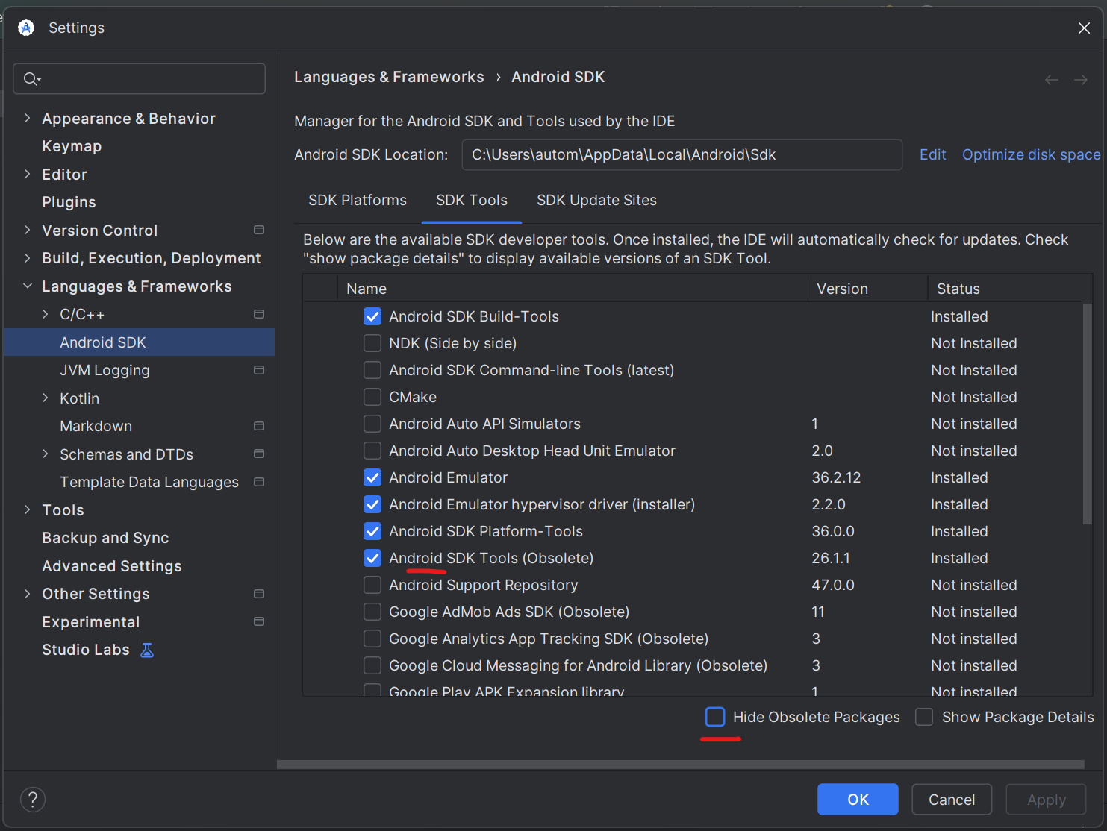
Node Path:
Gets automatically set. If not, then set below
- C:\Program Files\nodejs\
- C:\Program Files\nodejs\node_modules\npm\bin

- Install Appium Server
Run below commands in terminal
- npm install -g appium --force
- npm list -g appium
- where appium
- appium -v # make sure it shows version 3.x.x.

- Install Appium drivers
- appium driver list
- appium driver install uiautomator2

- Install IntelliJ
Download URL: IntelliJ IDEA | Other Versions

- Appium Inspector
Download URL: https://github.com/appium/appium-inspector/releases

Step by Step Appium & Android Setup Instructions (MAC)
- Install Homebrew
Use below commands:
- Run the command below to install Homebrew.
$ /bin/bash -c "$(curl -fsSL https://raw.githubusercontent.com/Homebrew/install/HEAD/install.sh)"
- Check which shell your Mac is using by running the below command.
$ echo $SHELL
- If it returns /bin/zsh -> your shell is zsh.
- If it returns /bin/bash -> your shell is bash.
- Run below command to link Homebrew to bash or zsh shell profile.
If you have zsh shell:
$ echo 'eval "$(/opt/homebrew/bin/brew shellenv)"' >> ~/.zprofile
If you have bash shell:
$ echo 'eval "$(/opt/homebrew/bin/brew shellenv)"' >> ~/.bash_profile
- Run below command to set Homebrew variables.
$ eval "$(/opt/homebrew/bin/brew shellenv)"
- Run below command to verify installation.
$ which brew # should show: /opt/homebrew/bin/brew

- Download Java
- Install from Java Archive Downloads - Java SE 17.0.12 and earlier
- Check installation in the terminal by running the command:
$ javac -version
or
Use below Homebrew commands for Java installation:
- Run the below command to install the JDK package.
$ brew install openjdk@17
- Run the below command to link JDK to your system.
$ sudo ln -sfn $(brew --prefix openjdk@17)/libexec/openjdk.jdk /Library/Java/JavaVirtualMachines/openjdk-17.jdk
- Run the below commands to verify installation.
$ which java # should show: /opt/homebrew/opt/openjdk@17/bin/java
$ javac -version # should show: javac 17.0.14

- Download Android Studio
- Install from Download Android Studio & App Tools - Android Developers
- Get the SDK folder path from the settings window. (/Users/<user-name>/Library/Android/sdk)

- Download Node
Use installer file from below url:
- Install from Node.js — Download Node.js®
- Check installation in terminal by running the command “node”.
or
Use below Homebrew commands for Node installation:
- $ brew install node # install node packages
- $ node -v # verify node installation
- $ npm -v # verify npm installation
- $ which node # should show: /opt/homebrew/bin/node

Note:
- Appium main.js file will be present in: /usr/local/lib/node_modules/appium/build/lib/main.js (if not installed via homebrew node)
or
/opt/homebrew/lib/node_modules/appium/build/lib/main.js (if installed via homebrew node)
- Node will be present in:
/usr/local/bin/node (if not installed via homebrew node)
or
/opt/homebrew/bin/node (if installed via homebrew node)

- Set Environment Variables
- Run below commands to use vim editor:
vim ~/.bash_profile # for bash shell
vim ~/.zprofile # for zsh shell
- Now copy and paste the below content. Don’t overwrite any existing content of the file:
# Homebrew
export PATH=/opt/homebrew/bin:$PATH
# Java
export JAVA_HOME=/opt/homebrew/opt/openjdk@17
export PATH=$JAVA_HOME/bin:$PATH
# Android
export ANDROID_HOME=/Users/<user-name>/Library/Android/sdk
export PATH=$ANDROID_HOME/emulator:$ANDROID_HOME/tools:$ANDROID_HOME/tools/bin:$ANDROID_HOME/platform-tools:$PATH

- Enter Esc + :wq # to save and quit

- Install Appium Server
Run below commands in terminal
- $ npm install -g appium --force
- $ npm list -g appium
- $ which appium # should show: /opt/homebrew/bin/appium
- $ appium -v # make sure it shows version 3.x.x.

- Install Appium drivers
- $ appium driver list
- $ appium driver install uiautomator2

- Install IntelliJ
Download URL: IntelliJ IDEA | Other Versions

- Appium Inspector
Download URL: https://github.com/appium/appium-inspector/releases
Note:
If Mac does not allow to open Appium Inspector app then run below command:
$ cd /Applications
$ xattr -d com.apple.quarantine "Appium Inspector.app"

Step by Step Appium & XCode Setup Instructions (MAC)
Pre-Conditions:
Follow steps mentioned in “Step by Step Appium & Android Setup Instructions (MAC)” to install the below components:
- Homebrew
- Java
- Node
- Appium
- Environment Variables
- IntelliJ
- Appium Inspector

- Install XCode
Download XCode from the App Store.
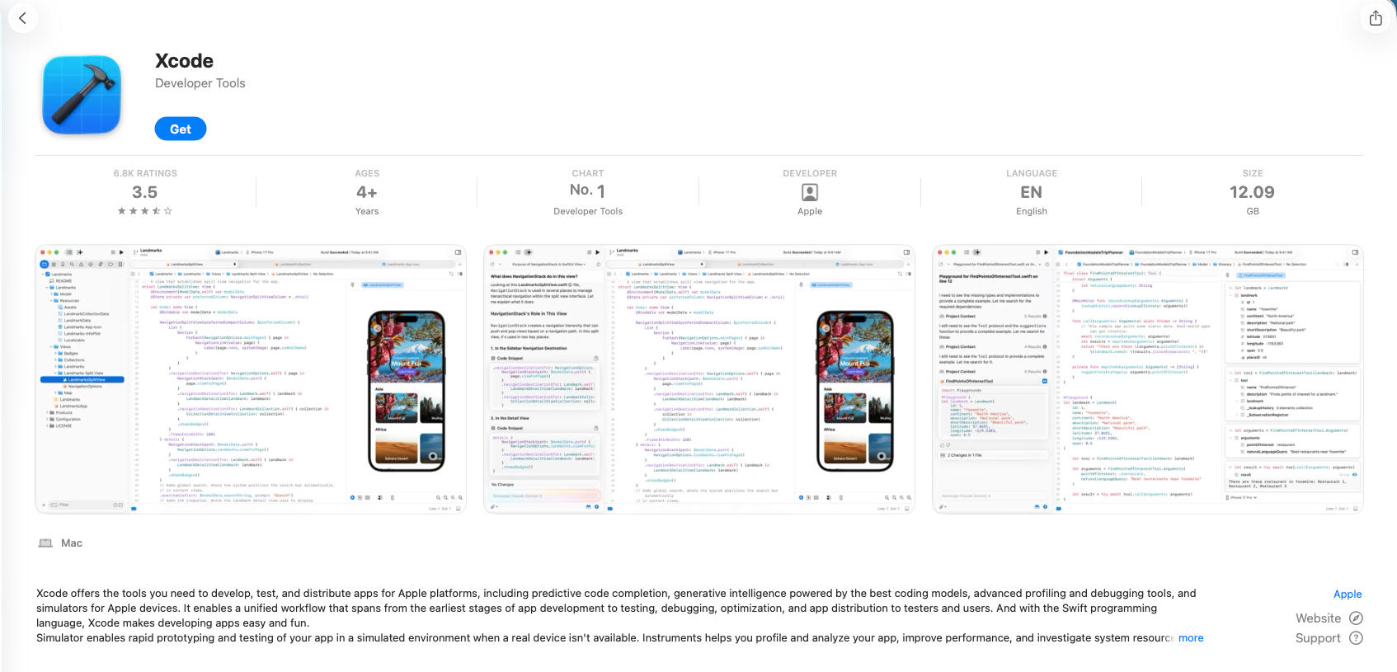

After installation, accept Terms and Conditions to proceed.
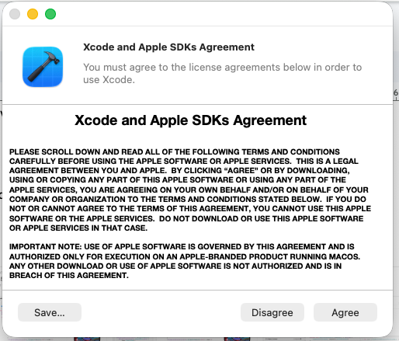
Download and install necessary components:
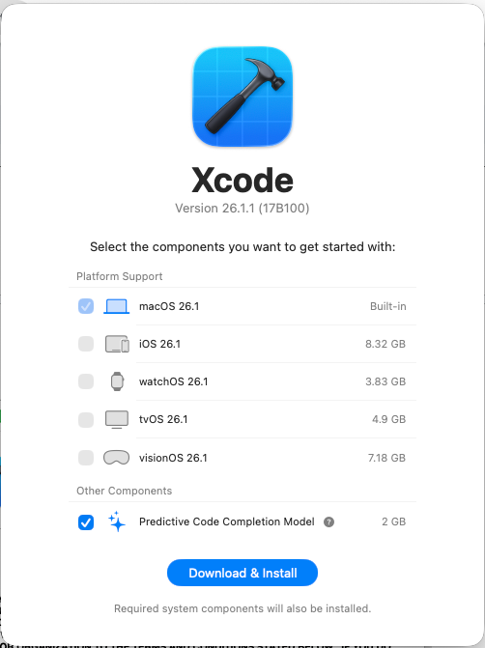
Once done, go to XCode -> Developer Tools -> Simulator.

- Add your Apple Id to XCode.
Go to XCode -> Settings -> Apple Accounts -> Add Apple Account.
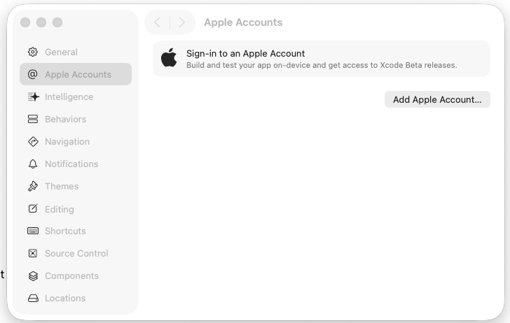
Note:
If you get an error like “Exception in thread "main" java.lang.RuntimeException: org.openqa.selenium.SessionNotCreatedException: Could not start a new session. Response code 500. Message: Unable to launch WebDriverAgent. Original error: xcodebuild failed with code 70. This usually indicates an issue with the local Xcode setup or WebDriverAgent project configuration or the driver-to-platform version mismatch.”
then follow below steps to fix it.
- Open the “WebDriverAgent.xcodeproj” file from the path “/Users/<user-name>/.appium/node_modules/appium-xcuitest-driver/node_modules/appium-webdriveragent”.
- This will open the WebDriverAgent project in XCode.
- Select WebDriverAgentLib, WebDriverAgentRunner and IntegrationApp from the dropdown shown in the screenshot.
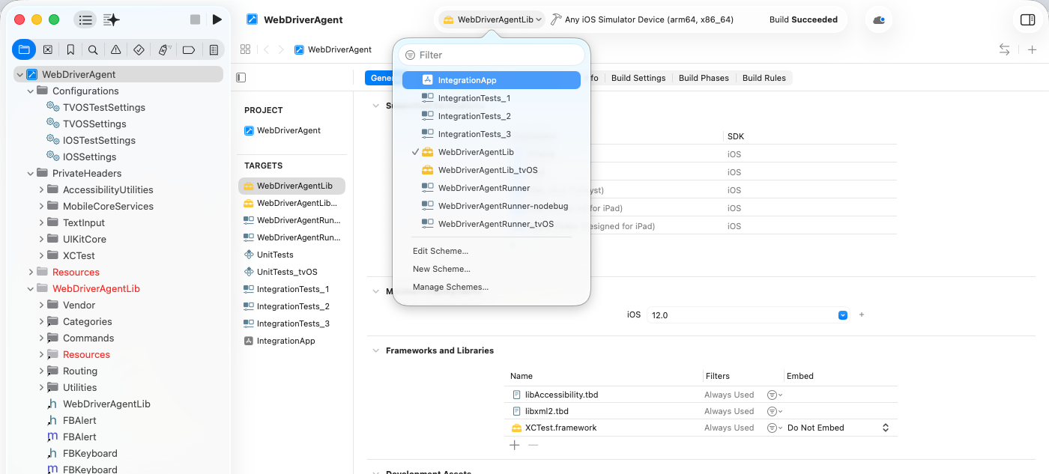
- Click on “Product -> Clean Build Folder” and then “Product -> Build”.

- Install Appium drivers
- $ appium driver list
- $ appium driver install xcuitest

